IP -TIME TO LIVE

Here we find lot of packets if we clearly observe we can see that request,and time to live exceeded .that means the data transfer has not been done yet.

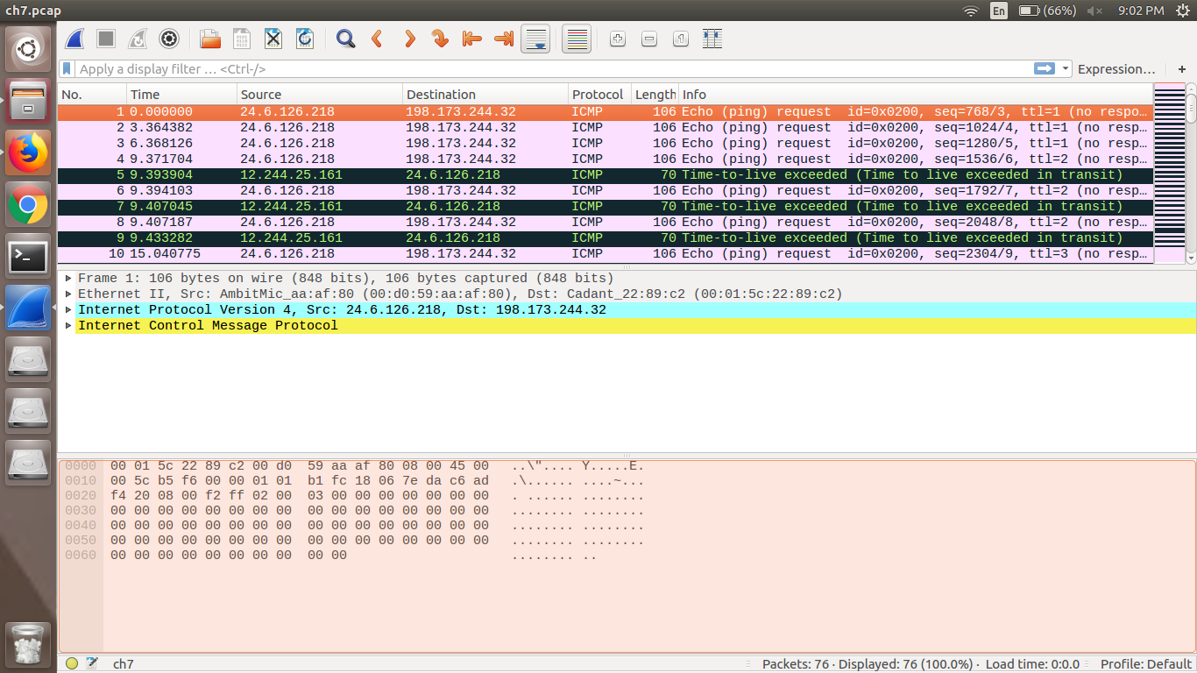

If we scroll down we can find at the last that there is request reply.it means that data transfer has been done at that particular packets.

As the challenge is to give TTL used to reach the targeted host in this ICMP exchange.as we can see that when TTL is 13 there is ICMP exchange so 13 is the answer.

